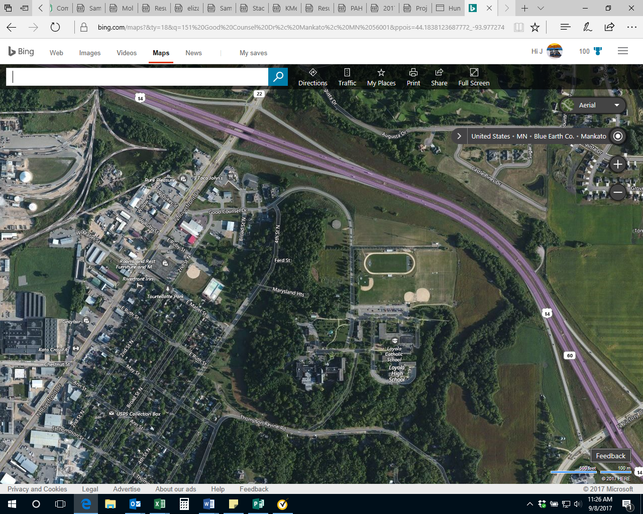

Partners for Affordable Housing Main Office

151 Good Counsel Dr., Suite 130

Mankato, MN

507-387-2115

